**Triple booting laptop:**

**OS used:**

Zorin OS

Linux mint

**Sorry for taking photographs instead of screenshot, my keyboard does not work properly.**

**Installing Zorin OS:**

* First creating an unallocated space to install the os.

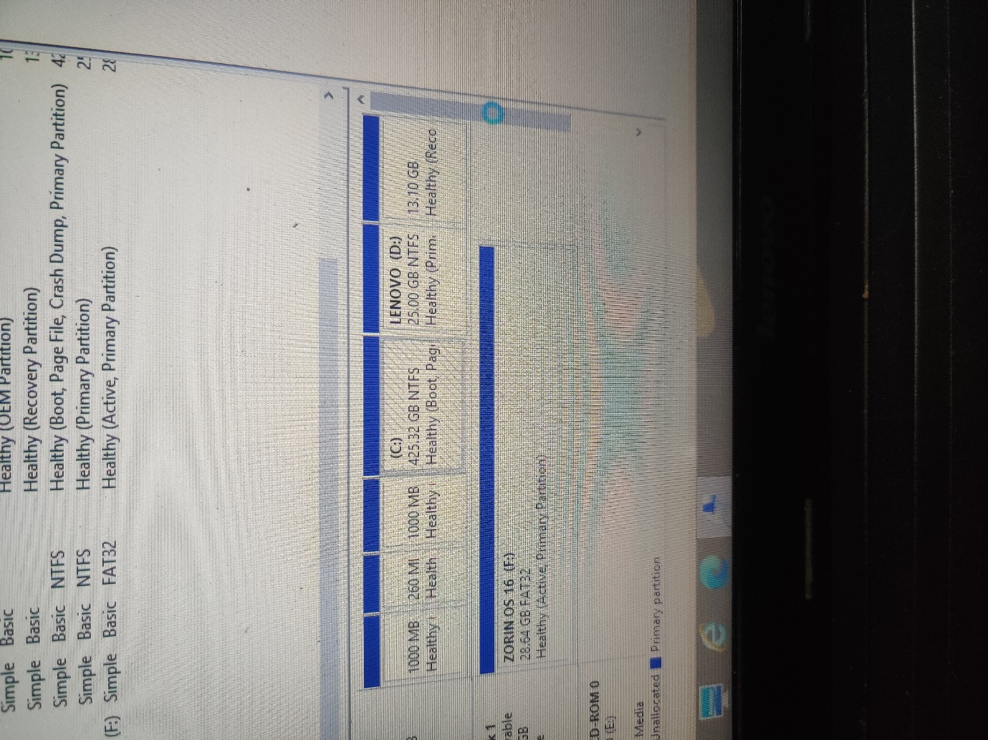

* Booting the os from bootable usb created by using the software balenaEtcher

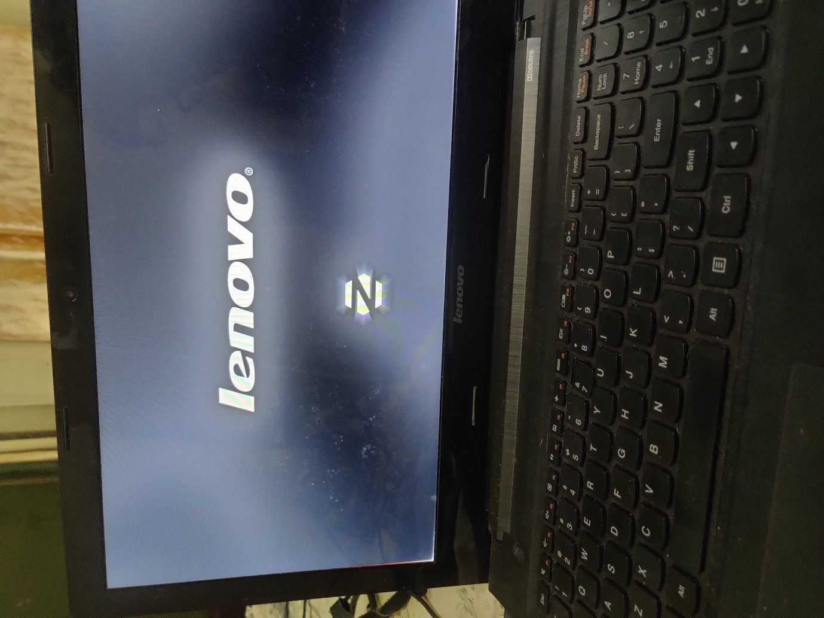

* The contents of the bootable usb is being checked

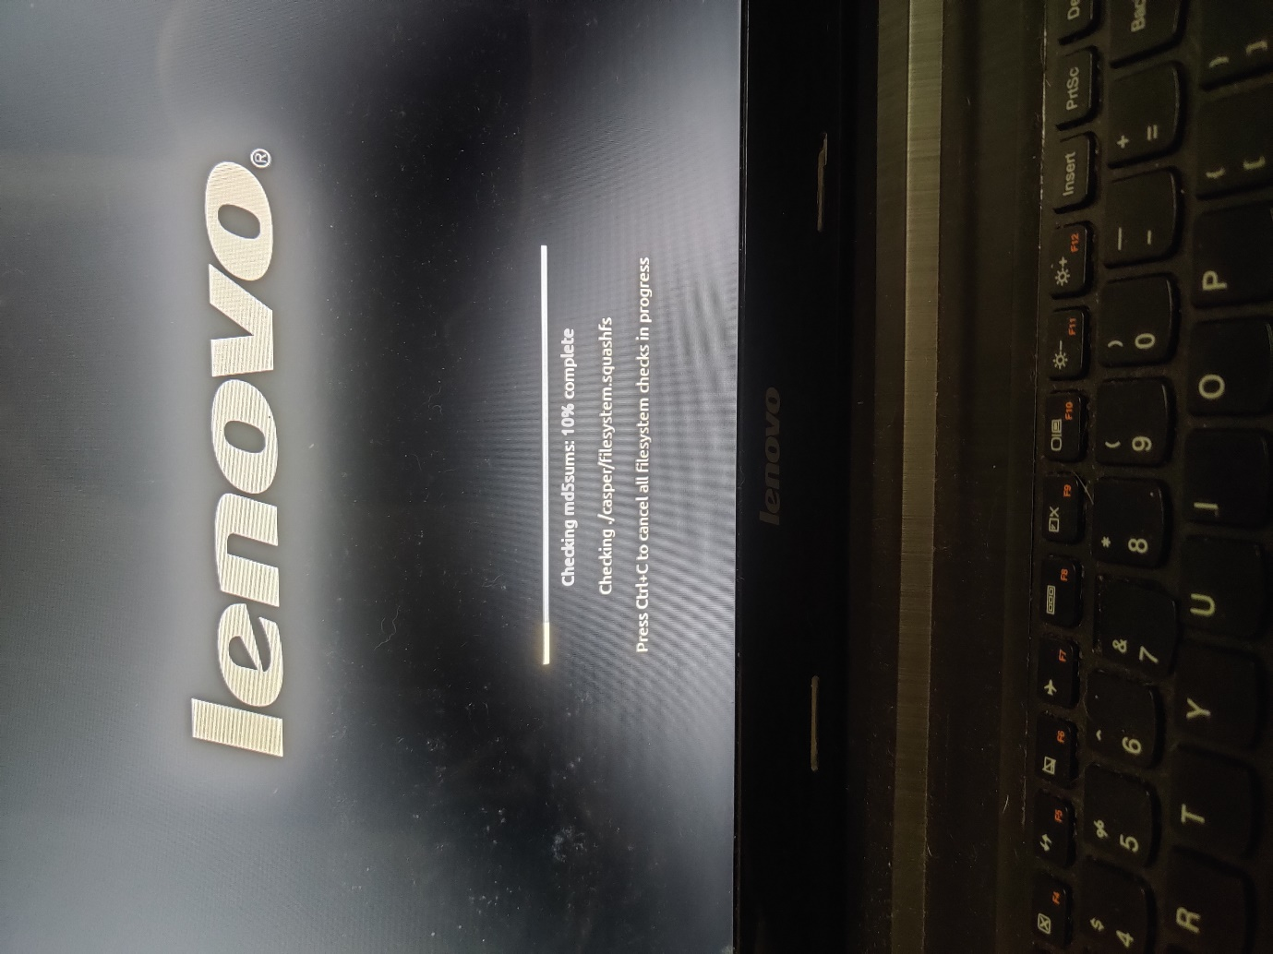

* Zorin installation page open up

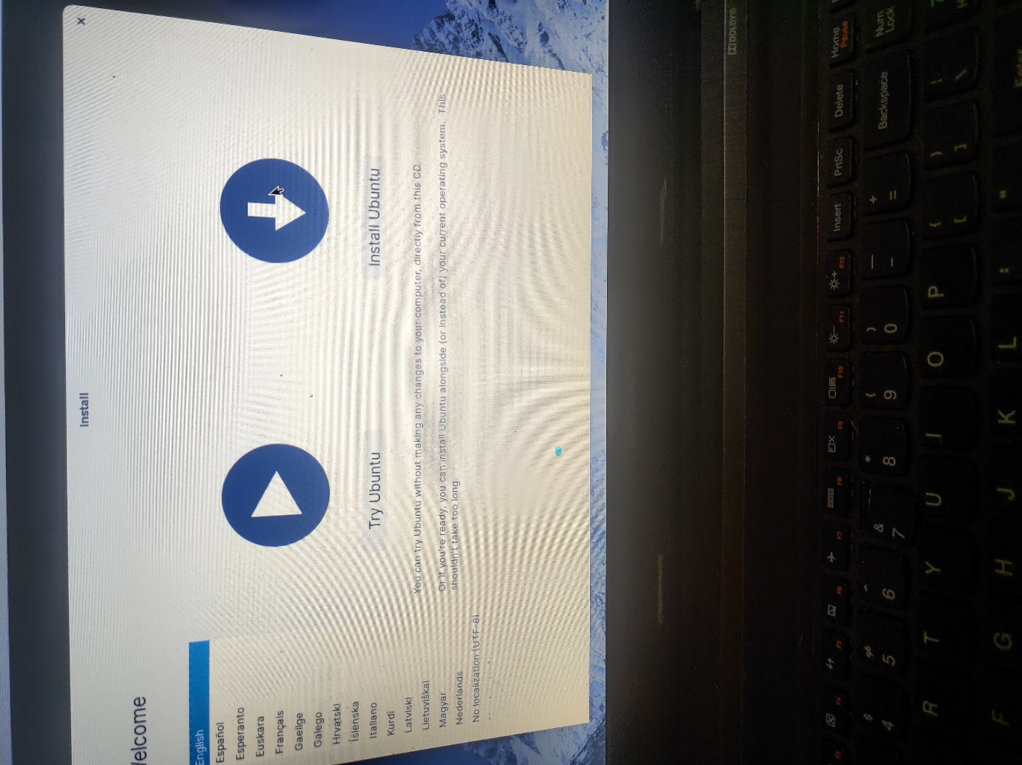

* Choose keyboard layout and various other setting for installation

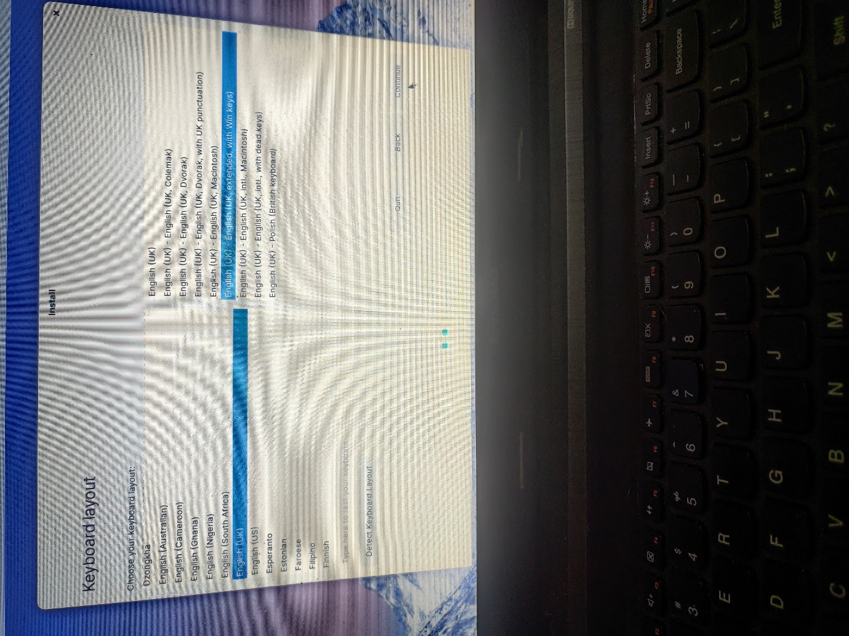

* When installation type is asked, I chose install along with windows boot manager

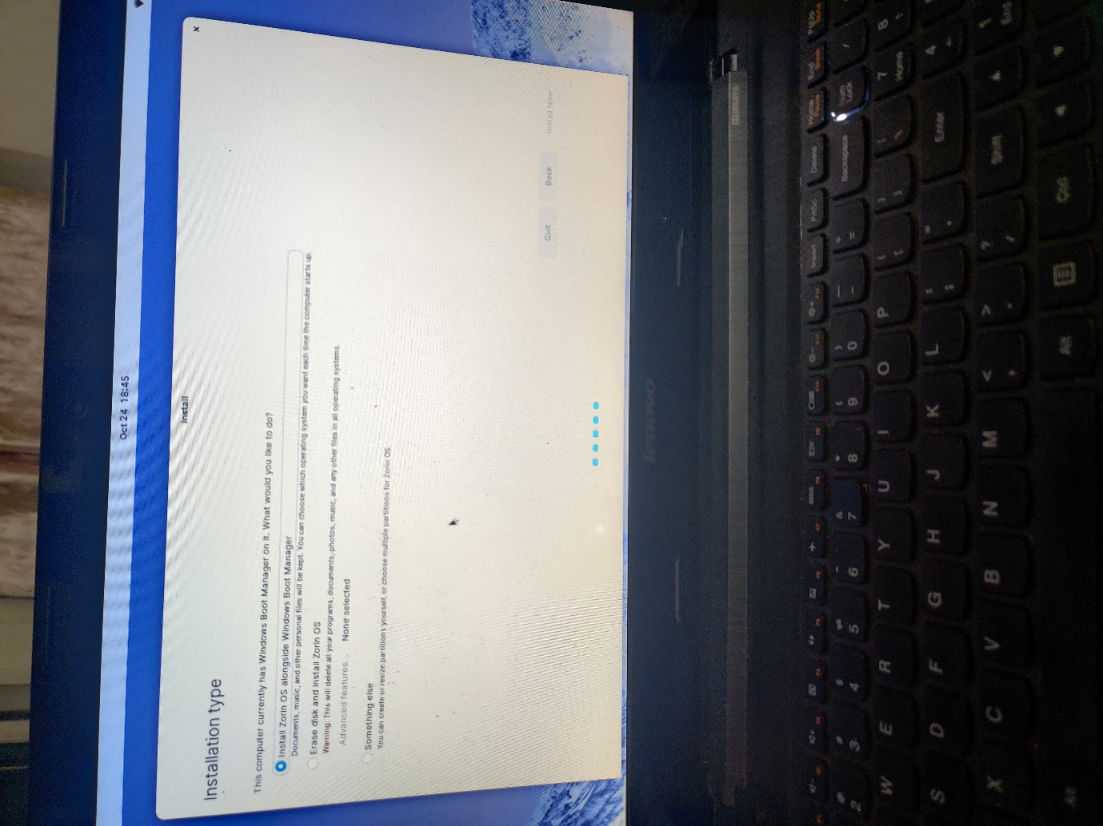

* After that type in personal information and continue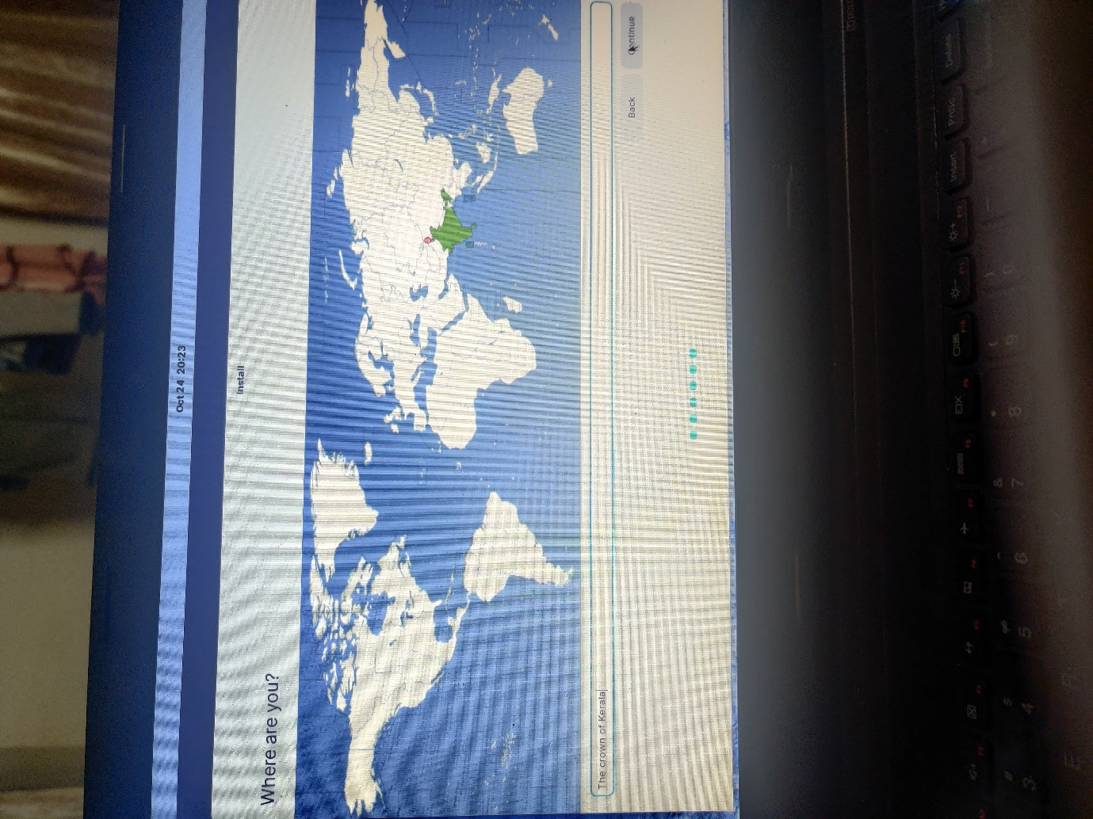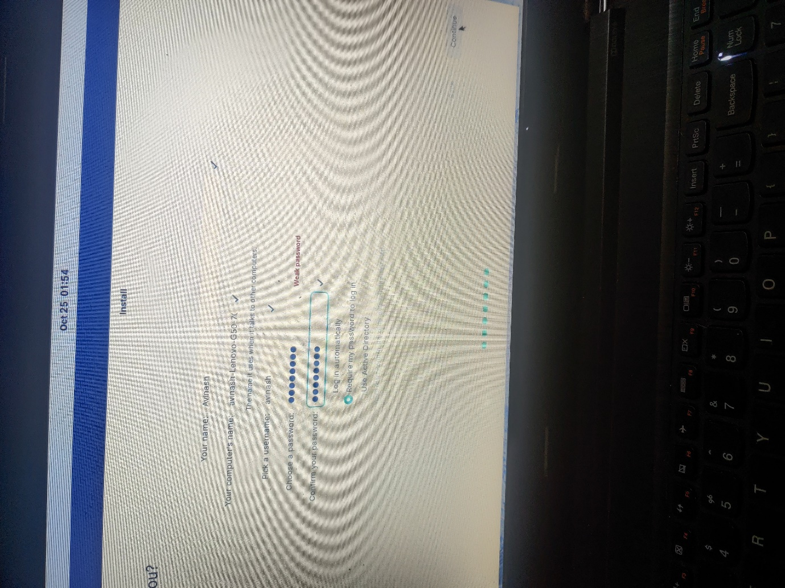
* After that installation will occur automatically

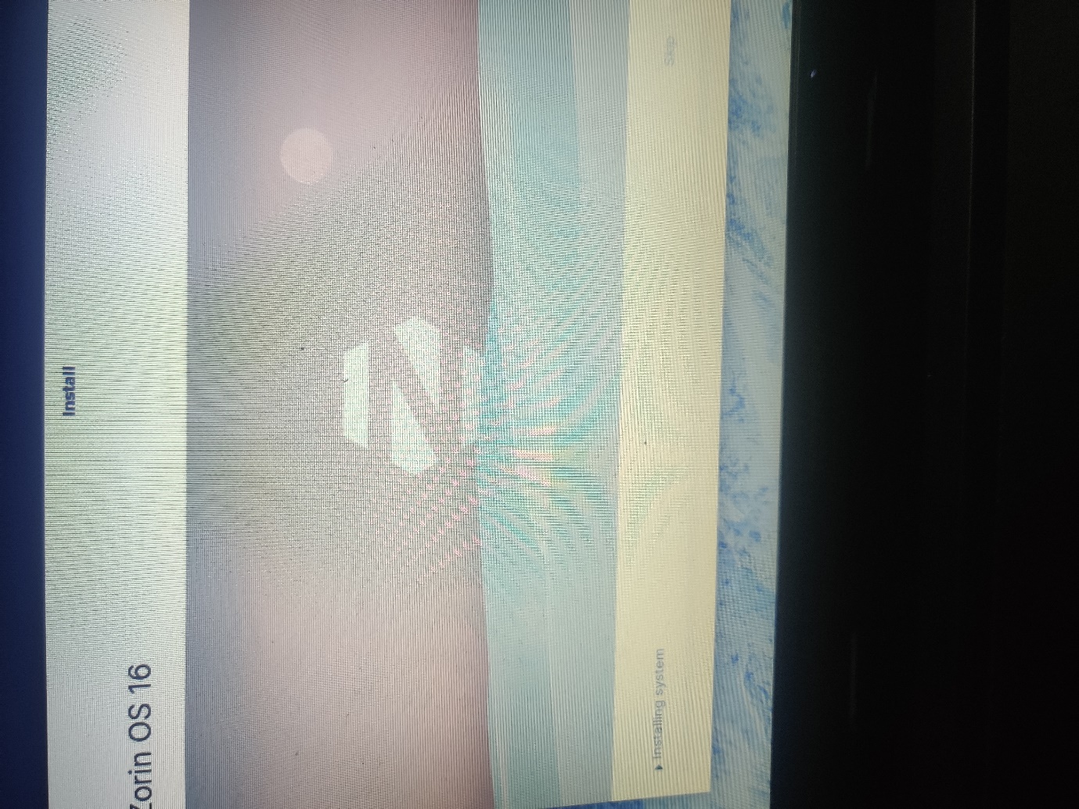

* Once the installation is complete we have to restart the laptop, and make sure to remove the usb while the machine restarts. When booting from next time the pc asks for option to boot from either windows or Zorin. Hence dual boot is successfully achieved.

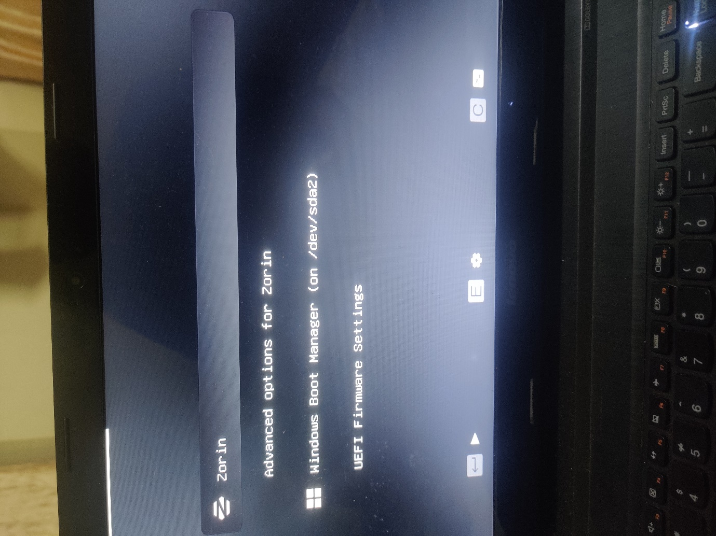

**Linux Mint OS:**

The steps done to download, and install is the same as Zroin OS, the picture of installation is given below:

1.

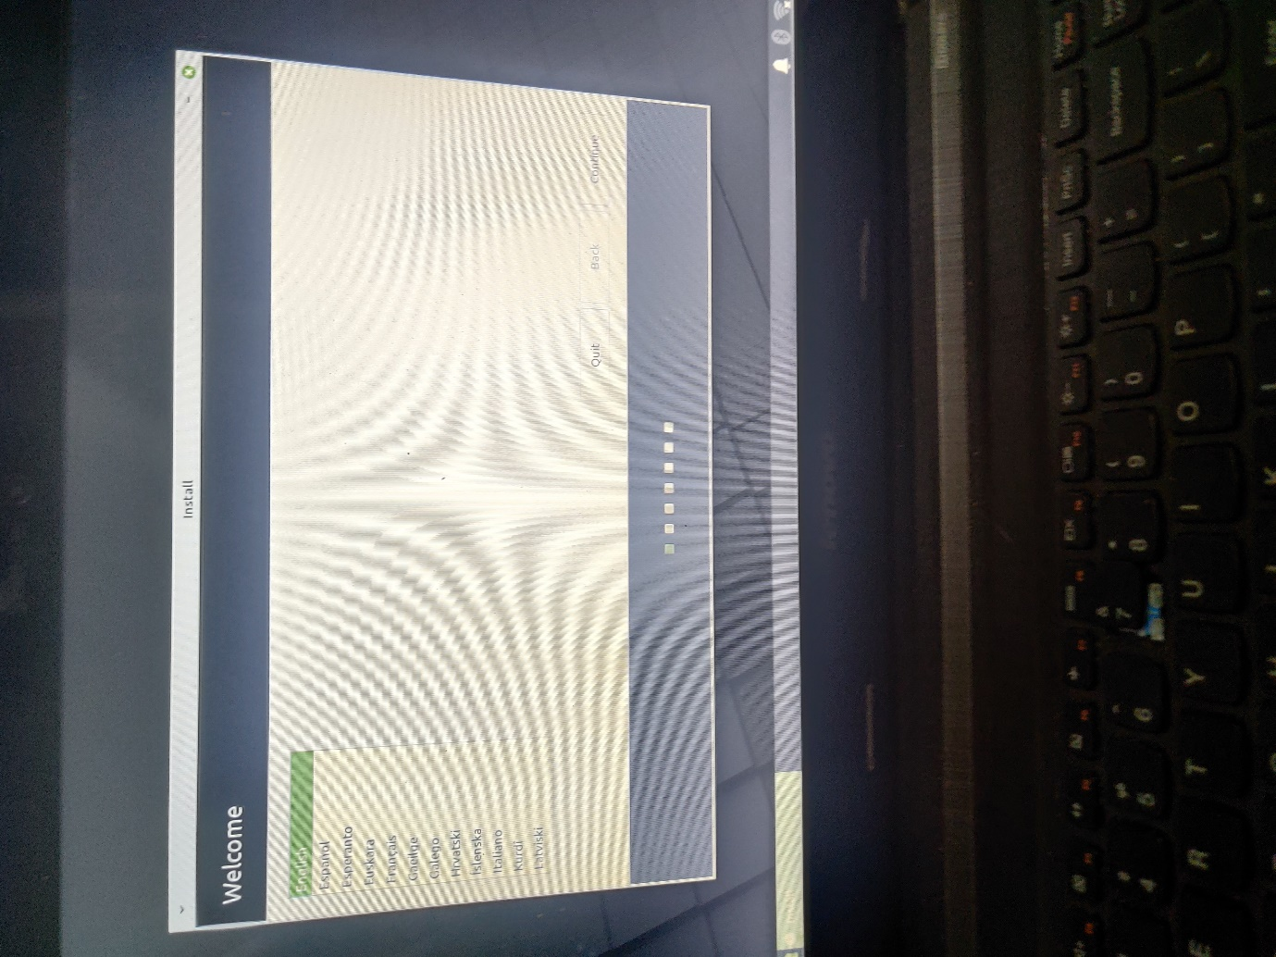

2.

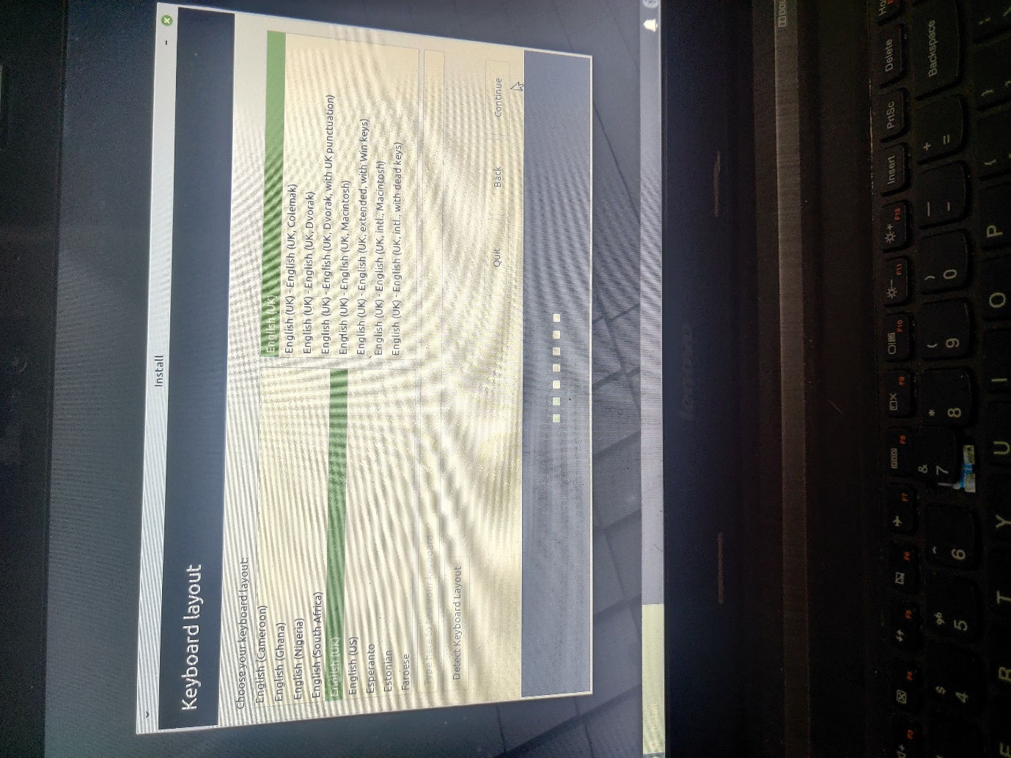

3. The difference from Zorin is that in this case I chose the option do something else and then from the unallocated space I created earlier divided some the portion to swap area and then installed the os to the rest unallocated area.

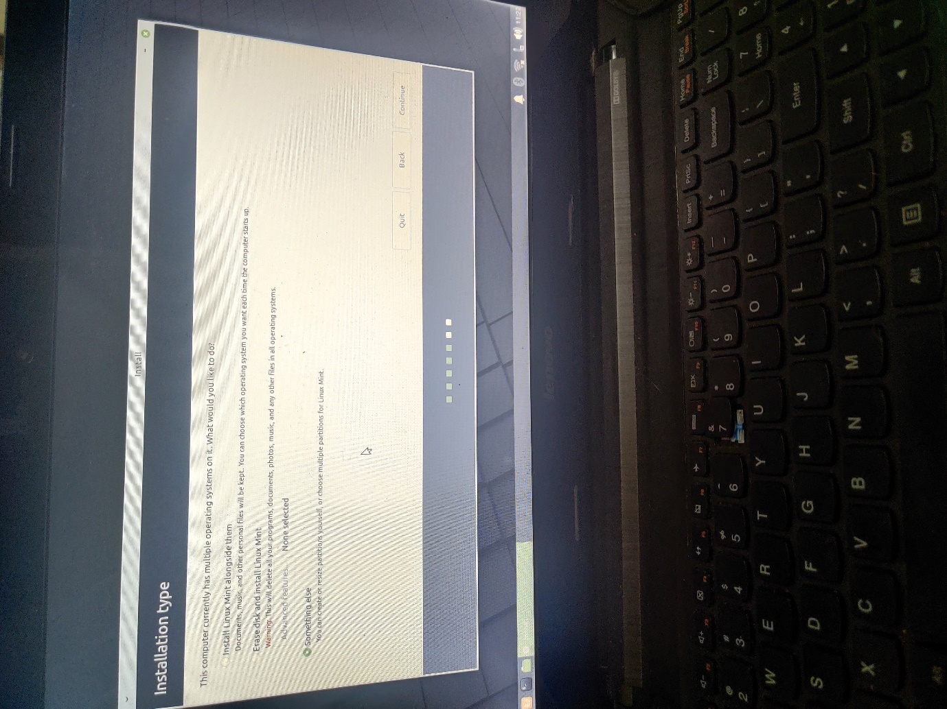

4.

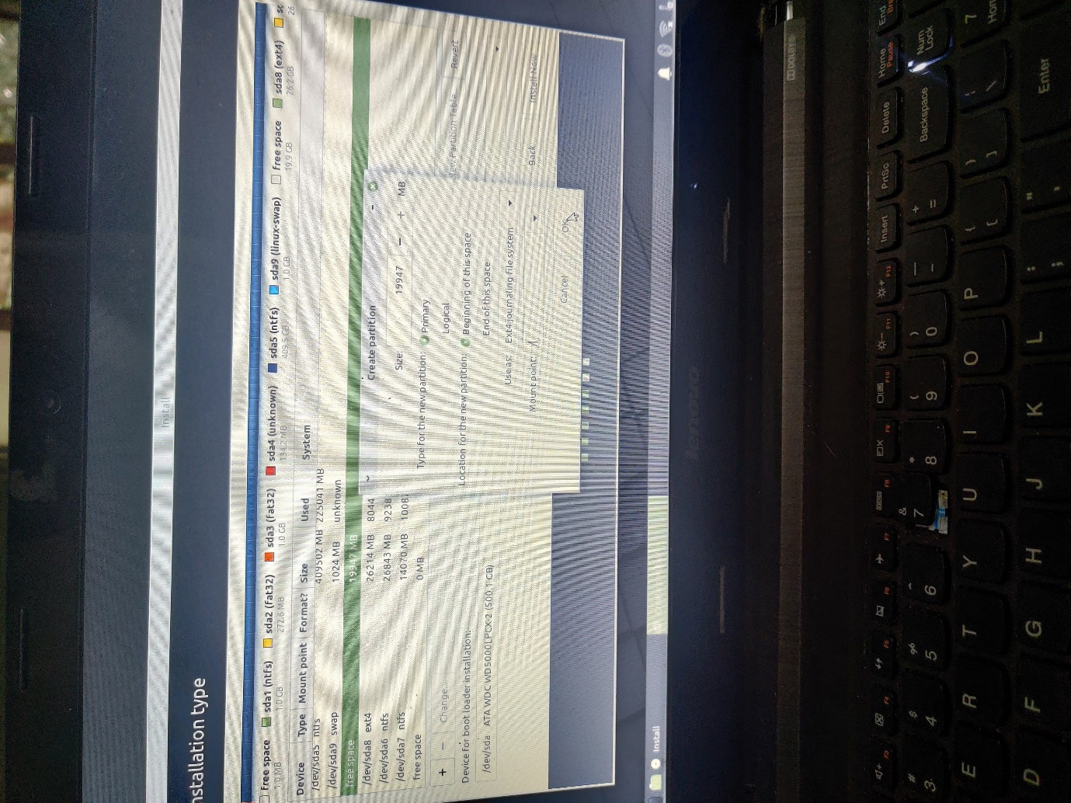

5.

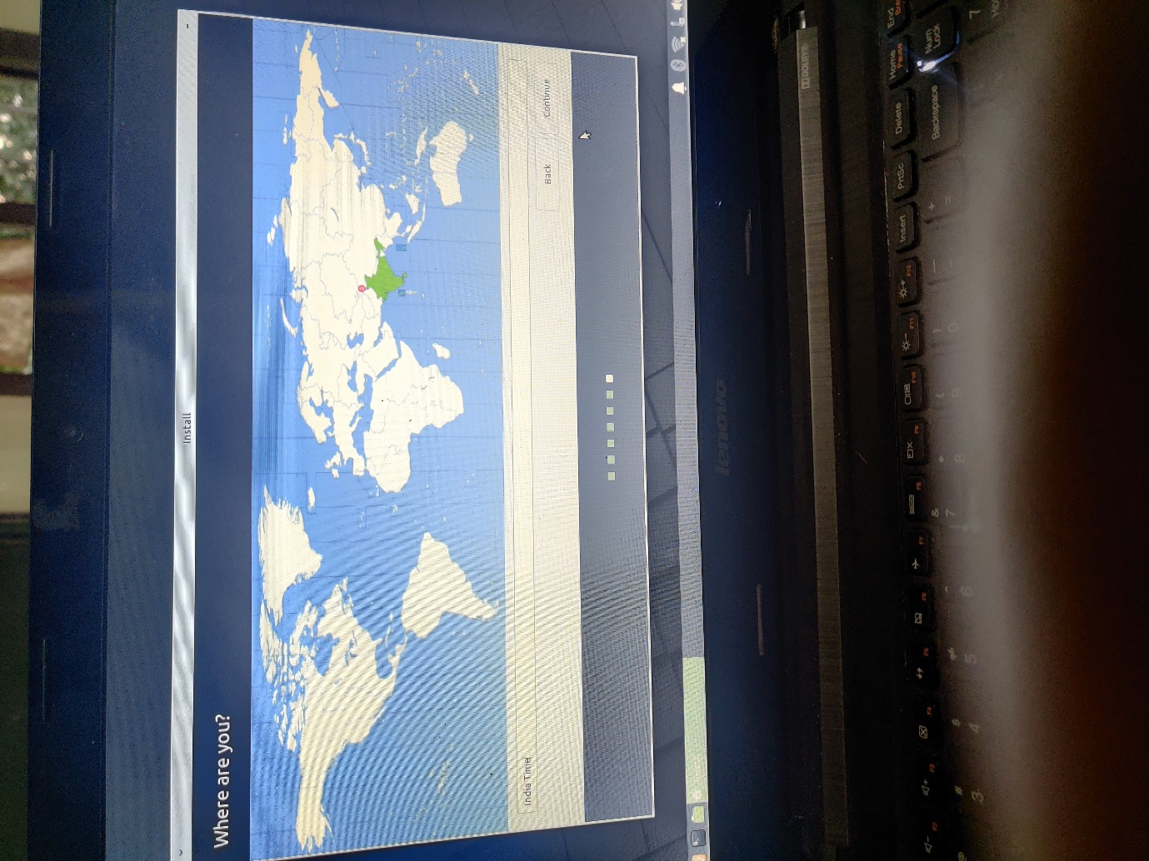

6.

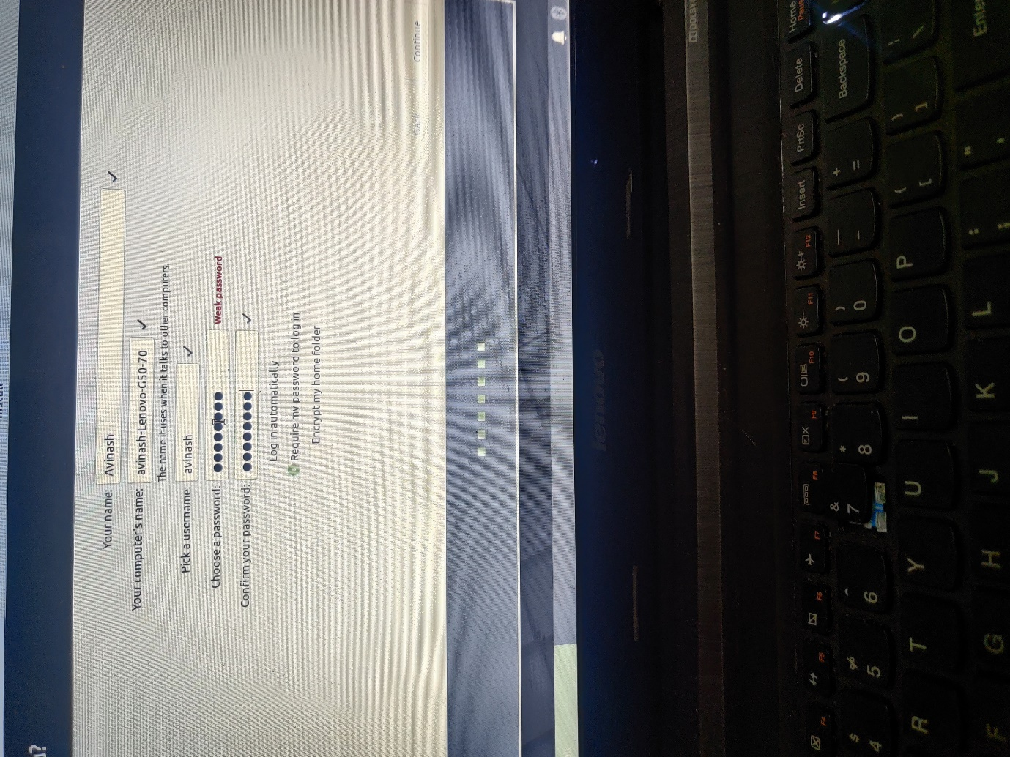

7.

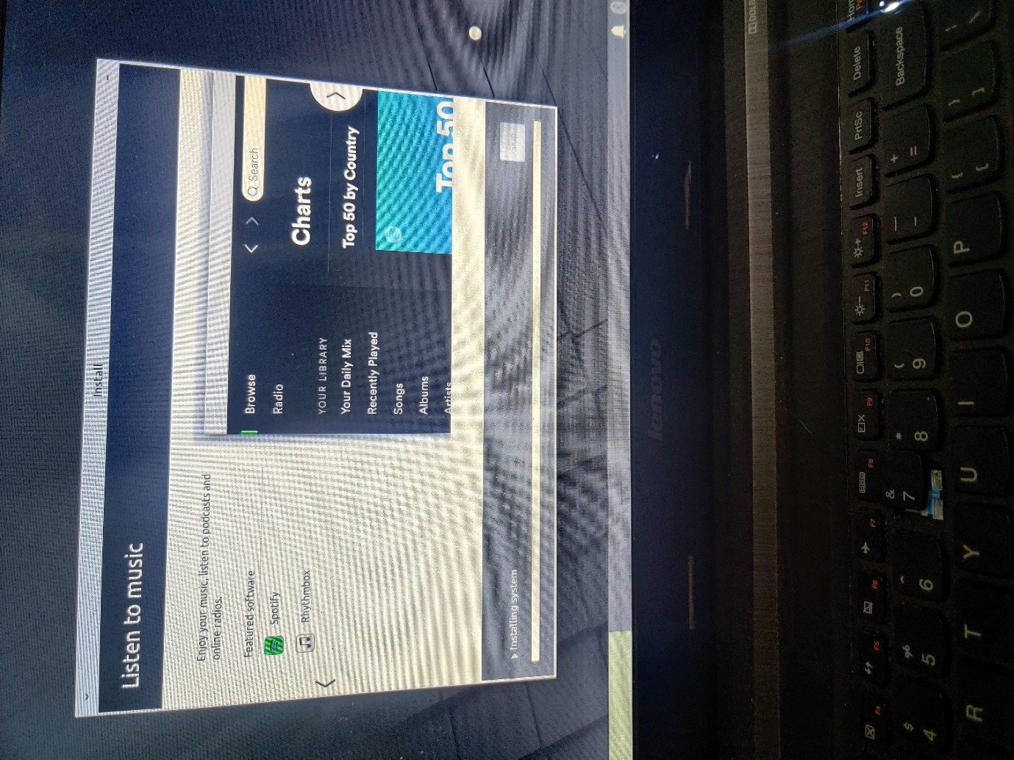

8. finally when we restart the pc after installation we achieve triple boot that is option to load into any of the three OS installed on the machine.

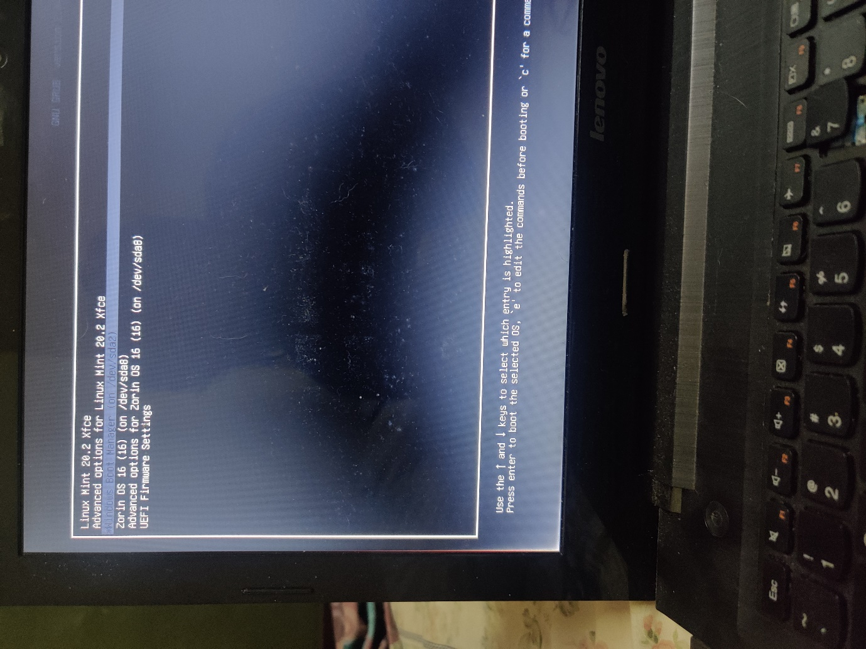

Questions:

Q1 What is kernel?

Ans. Kernel is the core component in an OS that helps facilitate communication between the hardware’s present and various software’s.

Kernel Type used by zorin: Monolithic (Linux)

Kernel Type used by Ubuntu mint: Linux Kernel 4.15

Q2 What is shell?

Ans. It is the outermost part of an OS, the presence of shell helps facilitate functions such as controlling processes hence mostly in the front-end interactions.

Q3 What is OS?

Ans. An OS is a software that acts as an interface between the computer hardware components and the user. OS helps facilitate the user to accomplish task by communicating and processing with the hardware and software components of a machine.

Q4. Constituents of an OS?

Ans.

* Process management
* File management
* Network management
* Main memory management
* Secondary storage management
* I/O device management
* Security management
* Command interpreter system

Submitted by:

Avinash Sabeen